W03 Learning Activities: CSS Selectors – Type, Universal, Class, ID
Overview
CSS selectors are the way you specify which elements you want to style. They form the subject line of a CSS rule.
Prepare
A CSS rule's selector is the first part of the rule that tells the browser which HTML elements should have the CSS property values applied. The elements selected by the selector are referred to as the subjects of the selector.
CSS Selector Types
CSS selectors can be different types, depending on whether you want to specify the element by its type, id, or class.
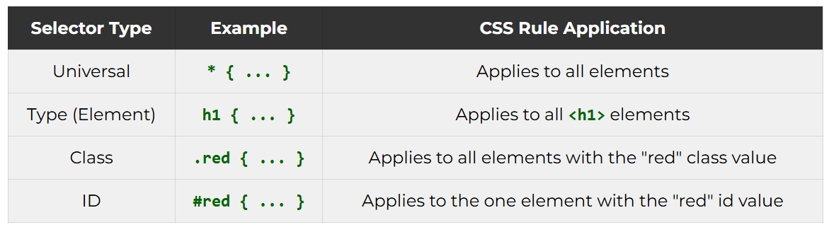
Using the Class Attribute
A class attribute can be applied to many elements in a document. More than one class can be applied to a single element. A class can be selected in CSS by using period (.) notation.
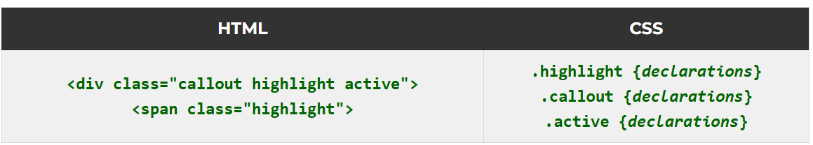
Using the ID Attribute
An id attribute can only be applied to one element per document, and each element may only have one id. The id can be selected by a CSS id selector using hash (#) notation.

Activity Instructions
- In VS Code, open the class-and-id.html file located in the week03 folder.
- Also open the class-and-id.css file located in the week03 styles subfolder.
- Display the page in your browser using Live/Five Server and review the layout and styles applied to the div elements.
- In VS Code, remove the highlight class from the second <div>, leaving only one class for that element named box. What happens? You may need to open the CSS file to see the difference.Check Your Understanding
<div class="box">
That second div is no longer styled with the "highlight" class and therefore loses those specific declarations.
- In the HTML, attempt to add another div element with the id attribute of "note" like this:
- <div id="note">
- <p>Testing the note ID.</p>
</div>
What happens in VS Code?Check Your Understanding
In VS Code, the editor warns you of a problem by highlighting the duplicate id attribute with a squiggly line.
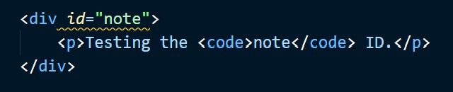
Note that the browser will actually apply the CSS style, but this application is an HTML validation error that the browser tries to ignore for you.

